Database Systems

Project – 2 (phase 1)

Group Members : -

Sudharsan Rajam : - (#1001874246)

Dhruv Patel : - (#1001748952)

Nahal Maymandi : - (#1001785613)

Introduction

The project 2 phase 1 consisted of information about a Car Rental company. The goal of this phase 1 was to create an Enhanced Entity Relationship model (EER) for the Car Rental database requirements provided and then convert this EER schema diagram to a relational database schema

Overview of EER Diagram

Enhanced Entity Relationship (EER) model is a high- level data model that incorporates the extensions to the original ER model.

EER models provides every features of ER model and in addition to that it has attribute or relationship inheritances, union types, specialization and generalization, sub-classes and super-classes.

EER Diagram design

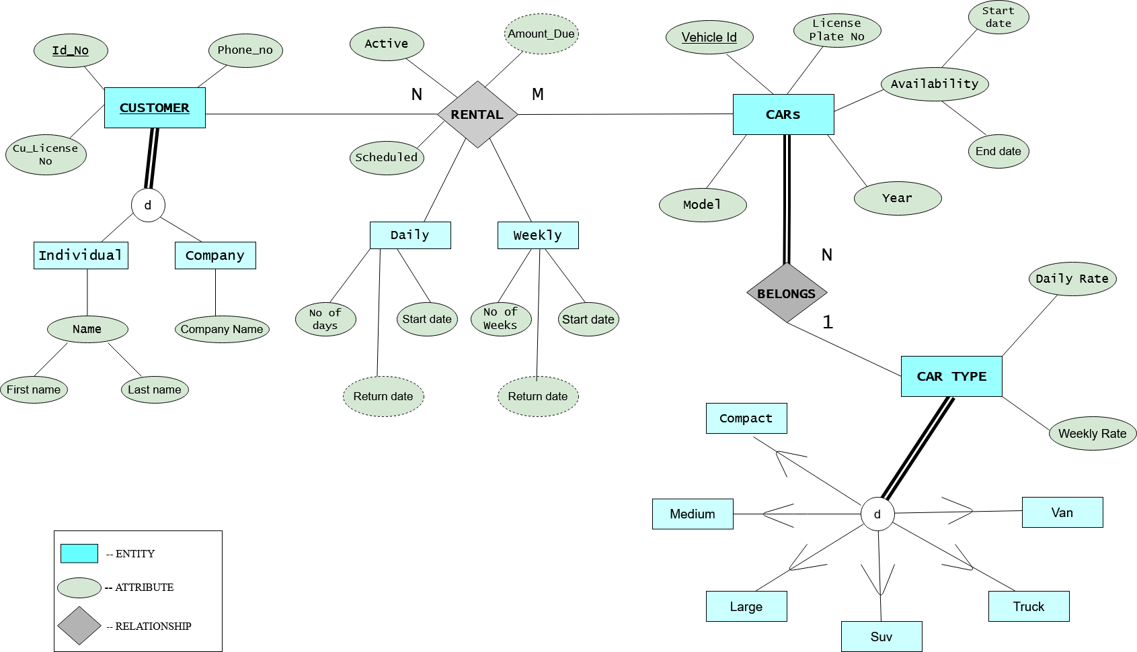

Tools Used -

The above EER diagram was designed from online drawing software (draw.io)

ER diagram missing requirements –

The assumptions made by us for the ER diagram which were not mentioned in database requirements are

* Cu_License No – This is the customer license number which will be required compulsorily by any car rental company to verify the customer’s driving approval
* Company – The rental of a car can be done by a company too and not just an individual, so the company entity and company name attribute has been added
* License plate No – In the entity Car, the database should also consist of the license plate number of every car

Cardinality Ratios – 2 Cardinality ratios are described for

EER diagram

* N : M – The Many to Many cardinality constraint is used

as there can be various number of customers and

can rent from various types of cars.

* N : 1 - The Many to One cardinality constraint is used

Between Car and Car types as there can be many

Customers renting a car but will be taking any

of car a specified type only.

Overview of Relational database schema

A relational database schema is an arrangement of integrity constraints and a set of relation schemas when we refer to a relational database, we implicitly include both its schema and its current state

The Relational database schema involves referential integrity constraint which is to be specified between two relations and is used to maintain the consistency between tuples in two relations

Conversion of EER to Relational Database schema

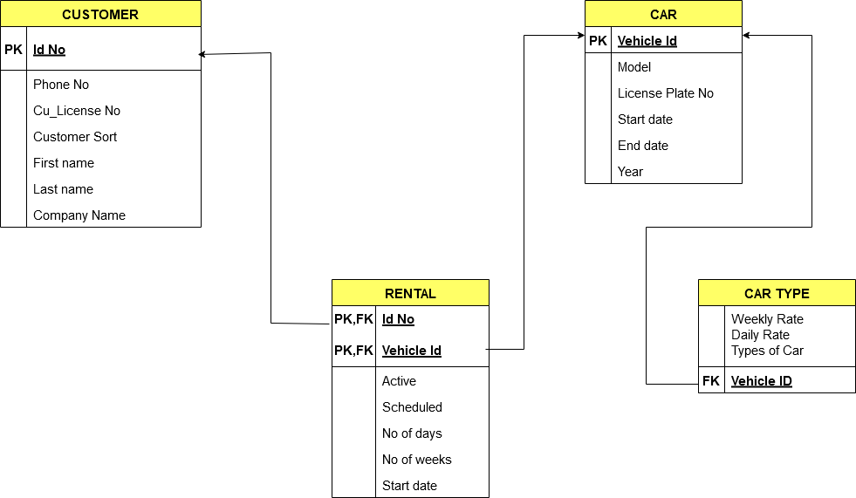

Tools Used -

The above EER diagram was designed from online drawing software (draw.io)

EER to Relational mapping choices and reasons :-

* Firstly, for all the entities, the primary keys were defined and then attributes present in the entities were defined.
* For composite attributes present in the entities, their sub-values were included instead of the attribute dividing them.
* Derived attributes were not included in the relational schema as the derived attributes can be calculated at the time of retrieval
* For the relationship Rental, the Primary key, Foreign key were chosen from Customer and Car Entities which are Id No and Vehicle Id respectively
* For the Car type Vehicle Id from the entity Car was declared as foreign key for the relational schema.

Conclusion

The EER diagram was created from the car rental database requirements with the help of a drawing tool software and was successfully converted into a Relational database schema with all the constraints, which had to be specified.

**HONOR CODE**

**I pledge, on my honour, to uphold UT Arlington's tradition of academic integrity, a tradition that values hard work and honest effort in the pursuit of academic excellence.**

**I promise that I will submit only work that I personally create or that I contribute to group collaborations, and I will appropriately reference any work from other sources. I will follow the highest standards of integrity and uphold the spirit of the Honour Code.**